1 run......

Downloading: 100%

464/464 [00:00<00:00, 12.6kB/s]

Downloading: 100%

270M/270M [00:06<00:00, 46.5MB/s]

training 1 epoch...

6.480921030044556 seconds used......

1 training finished! average train loss: 1.0831697252061632

evaluating...

Confusion matrix, without normalization

[[ 0 29 12]

[ 0 29 66]

[ 0 207 507]]

Normalized confusion matrix

[[0. 0.70731707 0.29268293]

[0. 0.30526316 0.69473684]

[0. 0.28991597 0.71008403]]

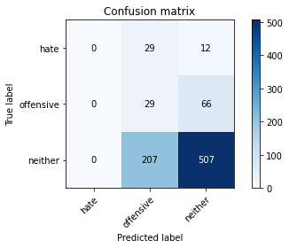

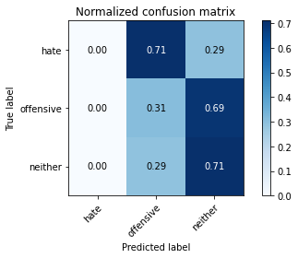

/opt/conda/lib/python3.7/site-packages/sklearn/metrics/_classification.py:1245: UndefinedMetricWarning: Precision and F-score are ill-defined and being set to 0.0 in labels with no predicted samples. Use `zero_division` parameter to control this behavior.

_warn_prf(average, modifier, msg_start, len(result))

/opt/conda/lib/python3.7/site-packages/sklearn/metrics/_classification.py:1245: UndefinedMetricWarning: Precision and F-score are ill-defined and being set to 0.0 in labels with no predicted samples. Use `zero_division` parameter to control this behavior.

_warn_prf(average, modifier, msg_start, len(result))

/opt/conda/lib/python3.7/site-packages/sklearn/metrics/_classification.py:1245: UndefinedMetricWarning: Precision and F-score are ill-defined and being set to 0.0 in labels with no predicted samples. Use `zero_division` parameter to control this behavior.

_warn_prf(average, modifier, msg_start, len(result))

precision recall f1-score support

hate 0.00 0.00 0.00 41

offensive 0.11 0.31 0.16 95

neither 0.87 0.71 0.78 714

accuracy 0.63 850

macro avg 0.33 0.34 0.31 850

weighted avg 0.74 0.63 0.67 850

average eval_loss: 0.8336870788141738, accuracy: 0.6305882352941177

training 2 epoch...

5.6145875453948975 seconds used......

2 training finished! average train loss: 0.9154404120312797

evaluating...

Confusion matrix, without normalization

[[ 2 37 2]

[ 0 85 10]

[ 15 365 334]]

Normalized confusion matrix

[[0.04878049 0.90243902 0.04878049]

[0. 0.89473684 0.10526316]

[0.0210084 0.51120448 0.46778711]]

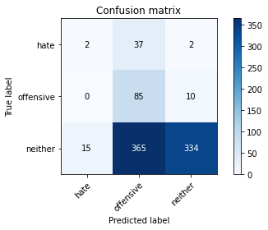

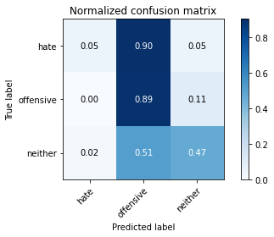

precision recall f1-score support

hate 0.12 0.05 0.07 41

offensive 0.17 0.89 0.29 95

neither 0.97 0.47 0.63 714

accuracy 0.50 850

macro avg 0.42 0.47 0.33 850

weighted avg 0.84 0.50 0.57 850

average eval_loss: 0.9302061518957448, accuracy: 0.49529411764705883

training 3 epoch...

5.594644069671631 seconds used......

3 training finished! average train loss: 0.7501015481021669

evaluating...

Confusion matrix, without normalization

[[ 24 8 9]

[ 18 58 19]

[119 117 478]]

Normalized confusion matrix

[[0.58536585 0.19512195 0.2195122 ]

[0.18947368 0.61052632 0.2 ]

[0.16666667 0.16386555 0.66946779]]

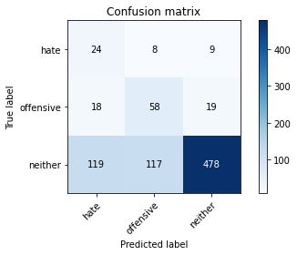

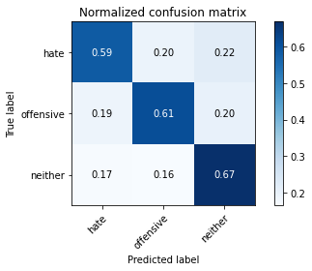

precision recall f1-score support

hate 0.15 0.59 0.24 41

offensive 0.32 0.61 0.42 95

neither 0.94 0.67 0.78 714

accuracy 0.66 850

macro avg 0.47 0.62 0.48 850

weighted avg 0.84 0.66 0.72 850

average eval_loss: 0.791565180864445, accuracy: 0.6588235294117647

training 4 epoch...

5.601311683654785 seconds used......

4 training finished! average train loss: 0.5771884255939059

evaluating...

Confusion matrix, without normalization

[[ 4 34 3]

[ 4 87 4]

[ 35 331 348]]

Normalized confusion matrix

[[0.09756098 0.82926829 0.07317073]

[0.04210526 0.91578947 0.04210526]

[0.04901961 0.46358543 0.48739496]]

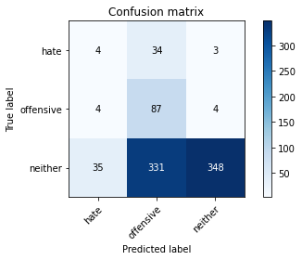

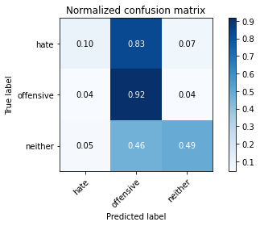

precision recall f1-score support

hate 0.09 0.10 0.10 41

offensive 0.19 0.92 0.32 95

neither 0.98 0.49 0.65 714

accuracy 0.52 850

macro avg 0.42 0.50 0.35 850

weighted avg 0.85 0.52 0.59 850

average eval_loss: 1.014632064935773, accuracy: 0.5164705882352941

training 5 epoch...

5.596761226654053 seconds used......

5 training finished! average train loss: 0.36778121814131737

evaluating...

Confusion matrix, without normalization

[[ 5 26 10]

[ 6 75 14]

[ 33 200 481]]

Normalized confusion matrix

[[0.12195122 0.63414634 0.24390244]

[0.06315789 0.78947368 0.14736842]

[0.04621849 0.28011204 0.67366947]]

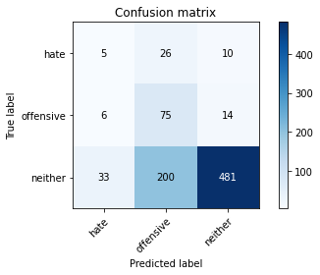

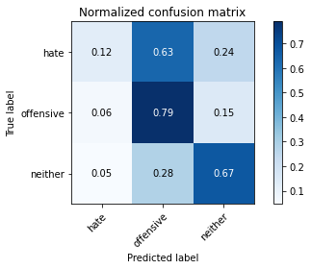

precision recall f1-score support

hate 0.11 0.12 0.12 41

offensive 0.25 0.79 0.38 95

neither 0.95 0.67 0.79 714

accuracy 0.66 850

macro avg 0.44 0.53 0.43 850

weighted avg 0.83 0.66 0.71 850

average eval_loss: 0.7734372991808626, accuracy: 0.66

training 6 epoch...

5.606714725494385 seconds used......

6 training finished! average train loss: 0.20250932654986778

evaluating...

Confusion matrix, without normalization

[[ 11 12 18]

[ 6 64 25]

[ 48 103 563]]

Normalized confusion matrix

[[0.26829268 0.29268293 0.43902439]

[0.06315789 0.67368421 0.26315789]

[0.06722689 0.1442577 0.78851541]]

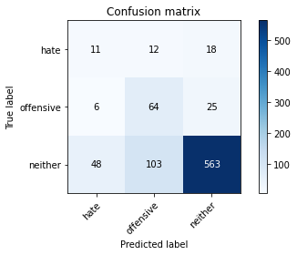

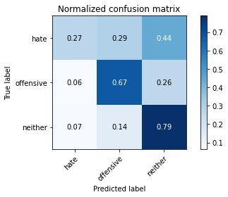

precision recall f1-score support

hate 0.17 0.27 0.21 41

offensive 0.36 0.67 0.47 95

neither 0.93 0.79 0.85 714

accuracy 0.75 850

macro avg 0.49 0.58 0.51 850

weighted avg 0.83 0.75 0.78 850

average eval_loss: 0.6504860425931077, accuracy: 0.7505882352941177

training 7 epoch...

5.570189952850342 seconds used......

7 training finished! average train loss: 0.0744375850384434

evaluating...

Confusion matrix, without normalization

[[ 12 14 15]

[ 8 68 19]

[ 50 151 513]]

Normalized confusion matrix

[[0.29268293 0.34146341 0.36585366]

[0.08421053 0.71578947 0.2 ]

[0.07002801 0.21148459 0.71848739]]

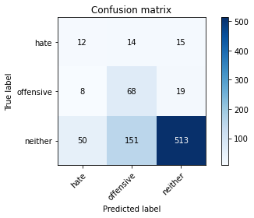

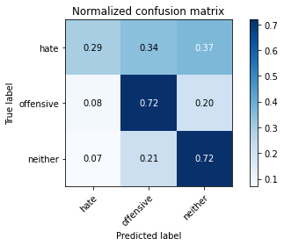

precision recall f1-score support

hate 0.17 0.29 0.22 41

offensive 0.29 0.72 0.41 95

neither 0.94 0.72 0.81 714

accuracy 0.70 850

macro avg 0.47 0.58 0.48 850

weighted avg 0.83 0.70 0.74 850

average eval_loss: 0.8671250043133664, accuracy: 0.6976470588235294

training 8 epoch...

5.593226432800293 seconds used......

8 training finished! average train loss: 0.02821095752167619

evaluating...

Confusion matrix, without normalization

[[ 10 14 17]

[ 5 64 26]

[ 37 132 545]]

Normalized confusion matrix

[[0.24390244 0.34146341 0.41463415]

[0.05263158 0.67368421 0.27368421]

[0.05182073 0.18487395 0.76330532]]

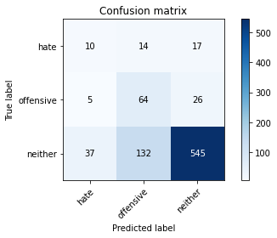

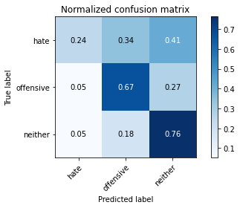

precision recall f1-score support

hate 0.19 0.24 0.22 41

offensive 0.30 0.67 0.42 95

neither 0.93 0.76 0.84 714

accuracy 0.73 850

macro avg 0.47 0.56 0.49 850

weighted avg 0.82 0.73 0.76 850

average eval_loss: 0.8463855927896707, accuracy: 0.7282352941176471

training 9 epoch...

5.675767660140991 seconds used......

9 training finished! average train loss: 0.01183198898151103

evaluating...

Confusion matrix, without normalization

[[ 12 14 15]

[ 9 68 18]

[ 63 137 514]]

Normalized confusion matrix

[[0.29268293 0.34146341 0.36585366]

[0.09473684 0.71578947 0.18947368]

[0.08823529 0.19187675 0.71988796]]

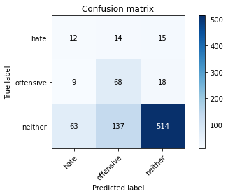

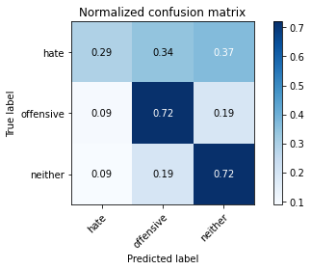

precision recall f1-score support

hate 0.14 0.29 0.19 41

offensive 0.31 0.72 0.43 95

neither 0.94 0.72 0.82 714

accuracy 0.70 850

macro avg 0.46 0.58 0.48 850

weighted avg 0.83 0.70 0.74 850

average eval_loss: 0.9969012104299699, accuracy: 0.6988235294117647

training 10 epoch...

5.594707012176514 seconds used......

10 training finished! average train loss: 0.007260517605269949

evaluating...

Confusion matrix, without normalization

[[ 13 11 17]

[ 7 65 23]

[ 57 125 532]]

Normalized confusion matrix

[[0.31707317 0.26829268 0.41463415]

[0.07368421 0.68421053 0.24210526]

[0.07983193 0.17507003 0.74509804]]

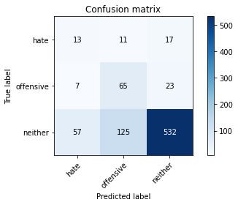

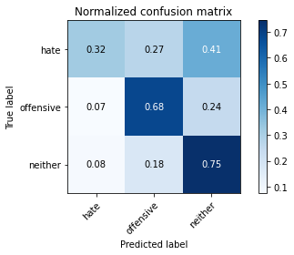

precision recall f1-score support

hate 0.17 0.32 0.22 41

offensive 0.32 0.68 0.44 95

neither 0.93 0.75 0.83 714

accuracy 0.72 850

macro avg 0.47 0.58 0.50 850

weighted avg 0.83 0.72 0.75 850

average eval_loss: 0.9920395521208817, accuracy: 0.7176470588235294

2 run......

training 1 epoch...

5.650462627410889 seconds used......

1 training finished! average train loss: 1.0623750802543428

evaluating...

Confusion matrix, without normalization

[[ 0 39 2]

[ 0 61 34]

[ 0 371 343]]

Normalized confusion matrix

[[0. 0.95121951 0.04878049]

[0. 0.64210526 0.35789474]

[0. 0.51960784 0.48039216]]

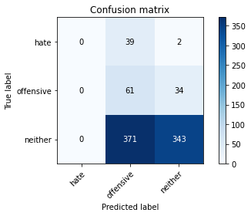

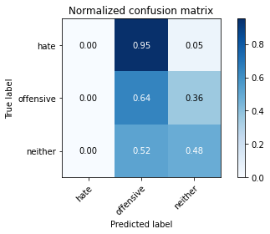

/opt/conda/lib/python3.7/site-packages/sklearn/metrics/_classification.py:1245: UndefinedMetricWarning: Precision and F-score are ill-defined and being set to 0.0 in labels with no predicted samples. Use `zero_division` parameter to control this behavior.

_warn_prf(average, modifier, msg_start, len(result))

/opt/conda/lib/python3.7/site-packages/sklearn/metrics/_classification.py:1245: UndefinedMetricWarning: Precision and F-score are ill-defined and being set to 0.0 in labels with no predicted samples. Use `zero_division` parameter to control this behavior.

_warn_prf(average, modifier, msg_start, len(result))

/opt/conda/lib/python3.7/site-packages/sklearn/metrics/_classification.py:1245: UndefinedMetricWarning: Precision and F-score are ill-defined and being set to 0.0 in labels with no predicted samples. Use `zero_division` parameter to control this behavior.

_warn_prf(average, modifier, msg_start, len(result))

precision recall f1-score support

hate 0.00 0.00 0.00 41

offensive 0.13 0.64 0.22 95

neither 0.91 0.48 0.63 714

accuracy 0.48 850

macro avg 0.34 0.37 0.28 850

weighted avg 0.77 0.48 0.55 850

average eval_loss: 0.9279315700364668, accuracy: 0.4752941176470588

training 2 epoch...

5.602209091186523 seconds used......

2 training finished! average train loss: 0.939934598075019

evaluating...

Confusion matrix, without normalization

[[ 0 21 20]

[ 0 35 60]

[ 0 143 571]]

Normalized confusion matrix

[[0. 0.51219512 0.48780488]

[0. 0.36842105 0.63157895]

[0. 0.20028011 0.79971989]]

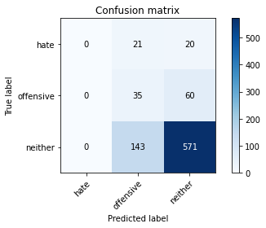

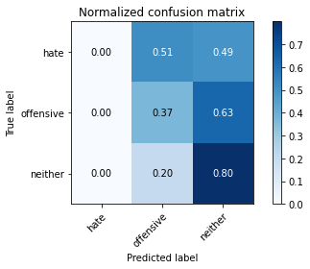

/opt/conda/lib/python3.7/site-packages/sklearn/metrics/_classification.py:1245: UndefinedMetricWarning: Precision and F-score are ill-defined and being set to 0.0 in labels with no predicted samples. Use `zero_division` parameter to control this behavior.

_warn_prf(average, modifier, msg_start, len(result))

/opt/conda/lib/python3.7/site-packages/sklearn/metrics/_classification.py:1245: UndefinedMetricWarning: Precision and F-score are ill-defined and being set to 0.0 in labels with no predicted samples. Use `zero_division` parameter to control this behavior.

_warn_prf(average, modifier, msg_start, len(result))

/opt/conda/lib/python3.7/site-packages/sklearn/metrics/_classification.py:1245: UndefinedMetricWarning: Precision and F-score are ill-defined and being set to 0.0 in labels with no predicted samples. Use `zero_division` parameter to control this behavior.

_warn_prf(average, modifier, msg_start, len(result))

precision recall f1-score support

hate 0.00 0.00 0.00 41

offensive 0.18 0.37 0.24 95

neither 0.88 0.80 0.84 714

accuracy 0.71 850

macro avg 0.35 0.39 0.36 850

weighted avg 0.76 0.71 0.73 850

average eval_loss: 0.7191804522691772, accuracy: 0.7129411764705882

training 3 epoch...

5.564716100692749 seconds used......

3 training finished! average train loss: 0.8034350656800799

evaluating...

Confusion matrix, without normalization

[[ 4 28 9]

[ 4 81 10]

[ 25 282 407]]

Normalized confusion matrix

[[0.09756098 0.68292683 0.2195122 ]

[0.04210526 0.85263158 0.10526316]

[0.03501401 0.39495798 0.57002801]]

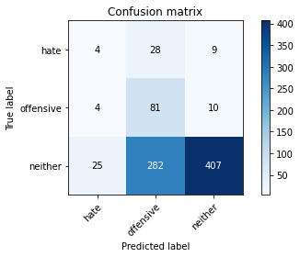

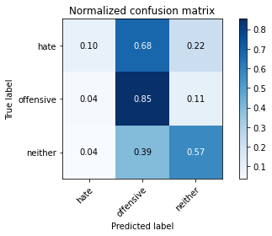

precision recall f1-score support

hate 0.12 0.10 0.11 41

offensive 0.21 0.85 0.33 95

neither 0.96 0.57 0.71 714

accuracy 0.58 850

macro avg 0.43 0.51 0.39 850

weighted avg 0.83 0.58 0.64 850

average eval_loss: 0.87743871520425, accuracy: 0.5788235294117647

training 4 epoch...

5.572690963745117 seconds used......

4 training finished! average train loss: 0.6089460915989346

evaluating...

Confusion matrix, without normalization

[[ 15 10 16]

[ 14 59 22]

[ 77 132 505]]

Normalized confusion matrix

[[0.36585366 0.24390244 0.3902439 ]

[0.14736842 0.62105263 0.23157895]

[0.10784314 0.18487395 0.70728291]]

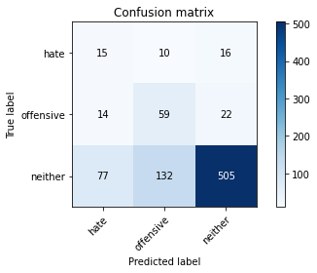

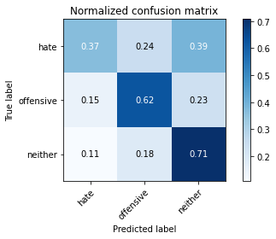

precision recall f1-score support

hate 0.14 0.37 0.20 41

offensive 0.29 0.62 0.40 95

neither 0.93 0.71 0.80 714

accuracy 0.68 850

macro avg 0.46 0.56 0.47 850

weighted avg 0.82 0.68 0.73 850

average eval_loss: 0.7361232946778453, accuracy: 0.6811764705882353

training 5 epoch...

5.594671249389648 seconds used......

5 training finished! average train loss: 0.4012943249609735

evaluating...

Confusion matrix, without normalization

[[ 9 18 14]

[ 5 77 13]

[ 31 219 464]]

Normalized confusion matrix

[[0.2195122 0.43902439 0.34146341]

[0.05263158 0.81052632 0.13684211]

[0.04341737 0.30672269 0.64985994]]

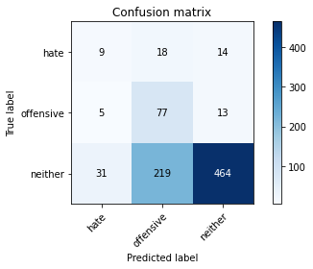

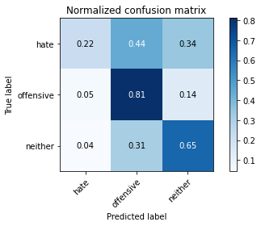

precision recall f1-score support

hate 0.20 0.22 0.21 41

offensive 0.25 0.81 0.38 95

neither 0.95 0.65 0.77 714

accuracy 0.65 850

macro avg 0.46 0.56 0.45 850

weighted avg 0.83 0.65 0.70 850

average eval_loss: 0.8878000160289365, accuracy: 0.6470588235294118

training 6 epoch...

5.643993616104126 seconds used......

6 training finished! average train loss: 0.27522091443339985

evaluating...

Confusion matrix, without normalization

[[ 16 10 15]

[ 18 55 22]

[ 85 137 492]]

Normalized confusion matrix

[[0.3902439 0.24390244 0.36585366]

[0.18947368 0.57894737 0.23157895]

[0.11904762 0.19187675 0.68907563]]

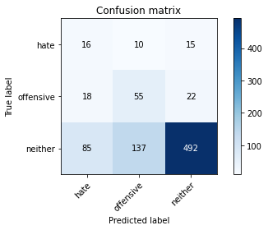

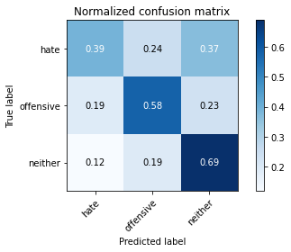

precision recall f1-score support

hate 0.13 0.39 0.20 41

offensive 0.27 0.58 0.37 95

neither 0.93 0.69 0.79 714

accuracy 0.66 850

macro avg 0.45 0.55 0.45 850

weighted avg 0.82 0.66 0.72 850

average eval_loss: 0.9044691052634356, accuracy: 0.6623529411764706

training 7 epoch...

5.60860538482666 seconds used......

7 training finished! average train loss: 0.14227877339969078

evaluating...

Confusion matrix, without normalization

[[ 15 18 8]

[ 14 74 7]

[ 76 225 413]]

Normalized confusion matrix

[[0.36585366 0.43902439 0.19512195]

[0.14736842 0.77894737 0.07368421]

[0.10644258 0.31512605 0.57843137]]

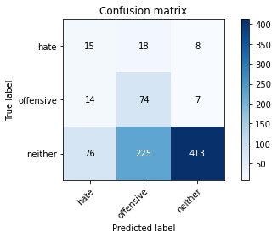

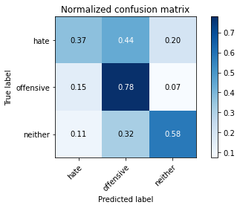

precision recall f1-score support

hate 0.14 0.37 0.21 41

offensive 0.23 0.78 0.36 95

neither 0.96 0.58 0.72 714

accuracy 0.59 850

macro avg 0.45 0.57 0.43 850

weighted avg 0.84 0.59 0.66 850

average eval_loss: 1.308764842728716, accuracy: 0.5905882352941176

training 8 epoch...

5.550520181655884 seconds used......

8 training finished! average train loss: 0.05545099591836333

evaluating...

Confusion matrix, without normalization

[[ 14 16 11]

[ 10 77 8]

[ 67 242 405]]

Normalized confusion matrix

[[0.34146341 0.3902439 0.26829268]

[0.10526316 0.81052632 0.08421053]

[0.09383754 0.33893557 0.56722689]]

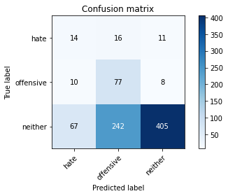

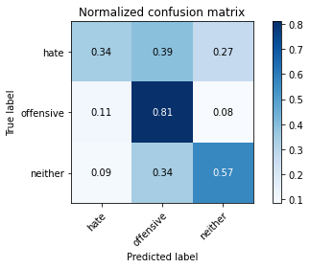

precision recall f1-score support

hate 0.15 0.34 0.21 41

offensive 0.23 0.81 0.36 95

neither 0.96 0.57 0.71 714

accuracy 0.58 850

macro avg 0.45 0.57 0.43 850

weighted avg 0.84 0.58 0.65 850

average eval_loss: 1.507505733693062, accuracy: 0.5835294117647059

training 9 epoch...

5.556793451309204 seconds used......

9 training finished! average train loss: 0.026228469201467104

evaluating...

Confusion matrix, without normalization

[[ 12 14 15]

[ 7 66 22]

[ 36 170 508]]

Normalized confusion matrix

[[0.29268293 0.34146341 0.36585366]

[0.07368421 0.69473684 0.23157895]

[0.05042017 0.23809524 0.71148459]]

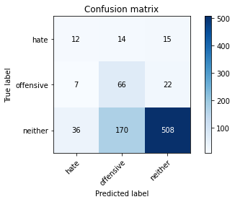

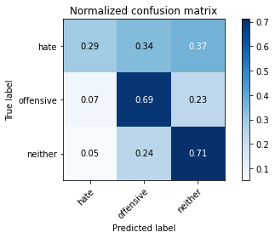

precision recall f1-score support

hate 0.22 0.29 0.25 41

offensive 0.26 0.69 0.38 95

neither 0.93 0.71 0.81 714

accuracy 0.69 850

macro avg 0.47 0.57 0.48 850

weighted avg 0.82 0.69 0.73 850

average eval_loss: 1.0696218458524103, accuracy: 0.6894117647058824

training 10 epoch...

5.5579235553741455 seconds used......

10 training finished! average train loss: 0.01132026868354943

evaluating...

Confusion matrix, without normalization

[[ 13 17 11]

[ 7 76 12]

[ 50 207 457]]

Normalized confusion matrix

[[0.31707317 0.41463415 0.26829268]

[0.07368421 0.8 0.12631579]

[0.07002801 0.28991597 0.64005602]]

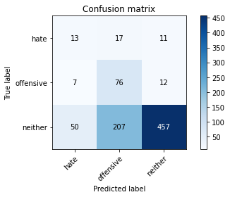

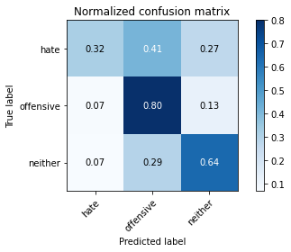

precision recall f1-score support

hate 0.19 0.32 0.23 41

offensive 0.25 0.80 0.38 95

neither 0.95 0.64 0.77 714

accuracy 0.64 850

macro avg 0.46 0.59 0.46 850

weighted avg 0.84 0.64 0.70 850

average eval_loss: 1.4408172134385813, accuracy: 0.6423529411764706

3 run......

training 1 epoch...

5.5627923011779785 seconds used......

1 training finished! average train loss: 1.076583057641983

evaluating...

Confusion matrix, without normalization

[[ 0 39 2]

[ 0 86 9]

[ 0 446 268]]

Normalized confusion matrix

[[0. 0.95121951 0.04878049]

[0. 0.90526316 0.09473684]

[0. 0.62464986 0.37535014]]

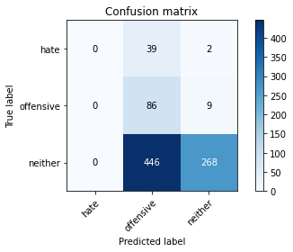

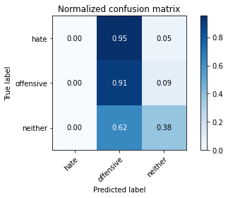

/opt/conda/lib/python3.7/site-packages/sklearn/metrics/_classification.py:1245: UndefinedMetricWarning: Precision and F-score are ill-defined and being set to 0.0 in labels with no predicted samples. Use `zero_division` parameter to control this behavior.

_warn_prf(average, modifier, msg_start, len(result))

/opt/conda/lib/python3.7/site-packages/sklearn/metrics/_classification.py:1245: UndefinedMetricWarning: Precision and F-score are ill-defined and being set to 0.0 in labels with no predicted samples. Use `zero_division` parameter to control this behavior.

_warn_prf(average, modifier, msg_start, len(result))

/opt/conda/lib/python3.7/site-packages/sklearn/metrics/_classification.py:1245: UndefinedMetricWarning: Precision and F-score are ill-defined and being set to 0.0 in labels with no predicted samples. Use `zero_division` parameter to control this behavior.

_warn_prf(average, modifier, msg_start, len(result))

precision recall f1-score support

hate 0.00 0.00 0.00 41

offensive 0.15 0.91 0.26 95

neither 0.96 0.38 0.54 714

accuracy 0.42 850

macro avg 0.37 0.43 0.27 850

weighted avg 0.82 0.42 0.48 850

average eval_loss: 0.9785225488418756, accuracy: 0.4164705882352941

training 2 epoch...

5.558903217315674 seconds used......

2 training finished! average train loss: 0.9141001519229677

evaluating...

Confusion matrix, without normalization

[[ 0 35 6]

[ 1 64 30]

[ 0 266 448]]

Normalized confusion matrix

[[0. 0.85365854 0.14634146]

[0.01052632 0.67368421 0.31578947]

[0. 0.37254902 0.62745098]]

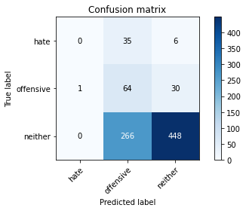

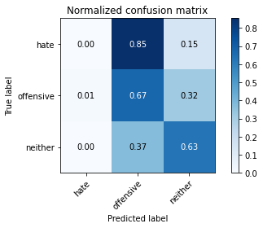

precision recall f1-score support

hate 0.00 0.00 0.00 41

offensive 0.18 0.67 0.28 95

neither 0.93 0.63 0.75 714

accuracy 0.60 850

macro avg 0.37 0.43 0.34 850

weighted avg 0.80 0.60 0.66 850

average eval_loss: 0.8670228823672893, accuracy: 0.6023529411764705

training 3 epoch...

5.599874973297119 seconds used......

3 training finished! average train loss: 0.7530689371956719

evaluating...

Confusion matrix, without normalization

[[ 5 14 22]

[ 3 33 59]

[ 13 67 634]]

Normalized confusion matrix

[[0.12195122 0.34146341 0.53658537]

[0.03157895 0.34736842 0.62105263]

[0.01820728 0.09383754 0.88795518]]

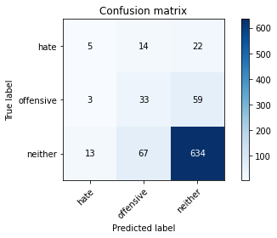

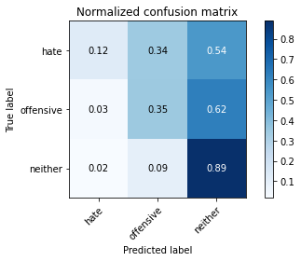

precision recall f1-score support

hate 0.24 0.12 0.16 41

offensive 0.29 0.35 0.32 95

neither 0.89 0.89 0.89 714

accuracy 0.79 850

macro avg 0.47 0.45 0.45 850

weighted avg 0.79 0.79 0.79 850

average eval_loss: 0.5820208346947681, accuracy: 0.7905882352941176

training 4 epoch...

5.592661380767822 seconds used......

4 training finished! average train loss: 0.583850716551145

evaluating...

Confusion matrix, without normalization

[[ 12 21 8]

[ 11 72 12]

[ 97 198 419]]

Normalized confusion matrix

[[0.29268293 0.51219512 0.19512195]

[0.11578947 0.75789474 0.12631579]

[0.13585434 0.27731092 0.58683473]]

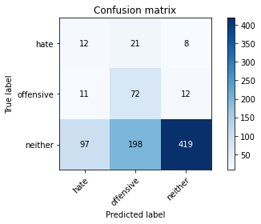

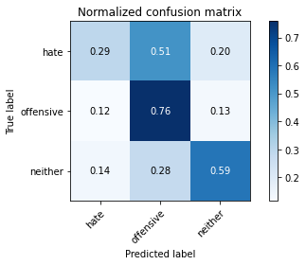

precision recall f1-score support

hate 0.10 0.29 0.15 41

offensive 0.25 0.76 0.37 95

neither 0.95 0.59 0.73 714

accuracy 0.59 850

macro avg 0.43 0.55 0.42 850

weighted avg 0.83 0.59 0.66 850

average eval_loss: 0.9302747677578482, accuracy: 0.591764705882353

training 5 epoch...

5.609153509140015 seconds used......

5 training finished! average train loss: 0.38576905243098736

evaluating...

Confusion matrix, without normalization

[[ 14 16 11]

[ 12 54 29]

[ 80 118 516]]

Normalized confusion matrix

[[0.34146341 0.3902439 0.26829268]

[0.12631579 0.56842105 0.30526316]

[0.11204482 0.16526611 0.72268908]]

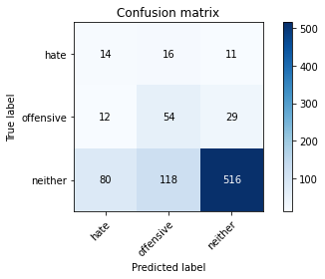

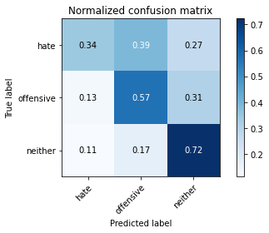

precision recall f1-score support

hate 0.13 0.34 0.19 41

offensive 0.29 0.57 0.38 95

neither 0.93 0.72 0.81 714

accuracy 0.69 850

macro avg 0.45 0.54 0.46 850

weighted avg 0.82 0.69 0.73 850

average eval_loss: 0.7729965188042369, accuracy: 0.6870588235294117

training 6 epoch...

5.554936647415161 seconds used......

6 training finished! average train loss: 0.2202765458366937

evaluating...

Confusion matrix, without normalization

[[ 13 17 11]

[ 12 62 21]

[ 77 162 475]]

Normalized confusion matrix

[[0.31707317 0.41463415 0.26829268]

[0.12631579 0.65263158 0.22105263]

[0.10784314 0.22689076 0.66526611]]

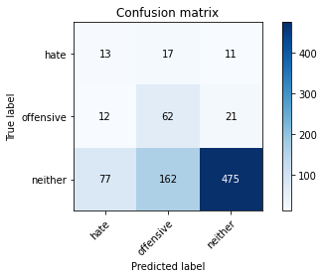

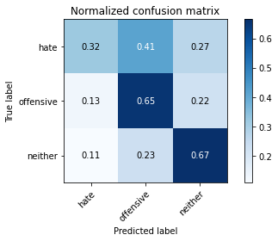

precision recall f1-score support

hate 0.13 0.32 0.18 41

offensive 0.26 0.65 0.37 95

neither 0.94 0.67 0.78 714

accuracy 0.65 850

macro avg 0.44 0.54 0.44 850

weighted avg 0.82 0.65 0.70 850

average eval_loss: 0.996615416002135, accuracy: 0.6470588235294118

training 7 epoch...

5.612314701080322 seconds used......

7 training finished! average train loss: 0.10799814126868215

evaluating...

Confusion matrix, without normalization

[[ 9 19 13]

[ 8 63 24]

[ 59 152 503]]

Normalized confusion matrix

[[0.2195122 0.46341463 0.31707317]

[0.08421053 0.66315789 0.25263158]

[0.08263305 0.21288515 0.70448179]]

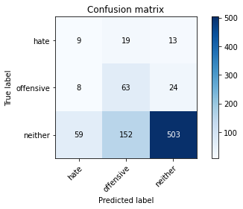

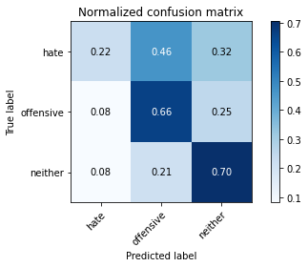

precision recall f1-score support

hate 0.12 0.22 0.15 41

offensive 0.27 0.66 0.38 95

neither 0.93 0.70 0.80 714

accuracy 0.68 850

macro avg 0.44 0.53 0.45 850

weighted avg 0.82 0.68 0.72 850

average eval_loss: 1.0392593686837097, accuracy: 0.6764705882352942

training 8 epoch...

5.562754154205322 seconds used......

8 training finished! average train loss: 0.04864965820322848

evaluating...

Confusion matrix, without normalization

[[ 8 15 18]

[ 4 37 54]

[ 34 97 583]]

Normalized confusion matrix

[[0.19512195 0.36585366 0.43902439]

[0.04210526 0.38947368 0.56842105]

[0.04761905 0.13585434 0.81652661]]

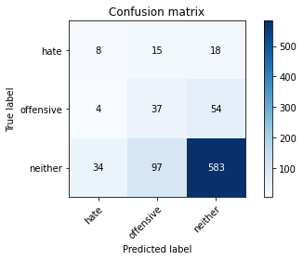

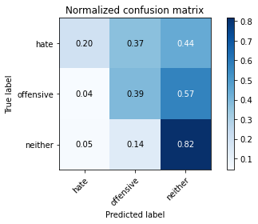

precision recall f1-score support

hate 0.17 0.20 0.18 41

offensive 0.25 0.39 0.30 95

neither 0.89 0.82 0.85 714

accuracy 0.74 850

macro avg 0.44 0.47 0.45 850

weighted avg 0.78 0.74 0.76 850

average eval_loss: 0.9302400594555534, accuracy: 0.7388235294117647

training 9 epoch...

5.598729133605957 seconds used......

9 training finished! average train loss: 0.027952533396374848

evaluating...

Confusion matrix, without normalization

[[ 14 12 15]

[ 8 51 36]

[ 63 117 534]]

Normalized confusion matrix

[[0.34146341 0.29268293 0.36585366]

[0.08421053 0.53684211 0.37894737]

[0.08823529 0.16386555 0.74789916]]

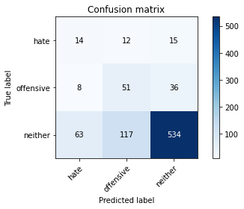

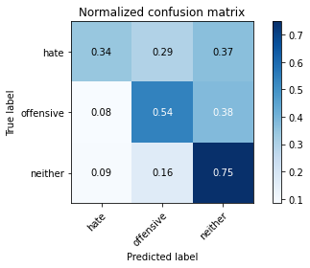

precision recall f1-score support

hate 0.16 0.34 0.22 41

offensive 0.28 0.54 0.37 95

neither 0.91 0.75 0.82 714

accuracy 0.70 850

macro avg 0.45 0.54 0.47 850

weighted avg 0.81 0.70 0.74 850

average eval_loss: 1.0482302523694587, accuracy: 0.7047058823529412

training 10 epoch...

5.593384504318237 seconds used......

10 training finished! average train loss: 0.014196031746299317

evaluating...

Confusion matrix, without normalization

[[ 6 20 15]

[ 5 55 35]

[ 29 141 544]]

Normalized confusion matrix

[[0.14634146 0.48780488 0.36585366]

[0.05263158 0.57894737 0.36842105]

[0.04061625 0.19747899 0.76190476]]

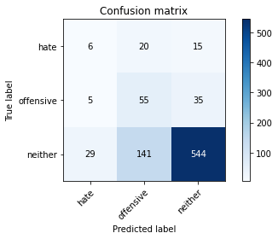

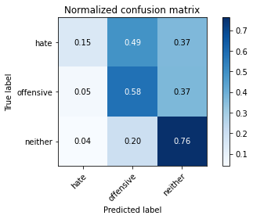

precision recall f1-score support

hate 0.15 0.15 0.15 41

offensive 0.25 0.58 0.35 95

neither 0.92 0.76 0.83 714

accuracy 0.71 850

macro avg 0.44 0.50 0.44 850

weighted avg 0.80 0.71 0.75 850

average eval_loss: 1.1269979045921288, accuracy: 0.711764705882353

4 run......

training 1 epoch...

5.602543115615845 seconds used......

1 training finished! average train loss: 1.0731997854179807

evaluating...

Confusion matrix, without normalization

[[ 0 40 1]

[ 0 84 11]

[ 0 477 237]]

Normalized confusion matrix

[[0. 0.97560976 0.02439024]

[0. 0.88421053 0.11578947]

[0. 0.66806723 0.33193277]]

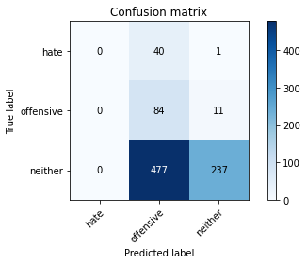

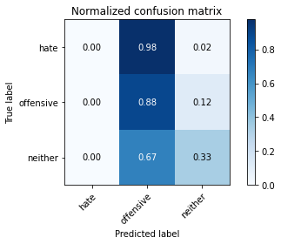

/opt/conda/lib/python3.7/site-packages/sklearn/metrics/_classification.py:1245: UndefinedMetricWarning: Precision and F-score are ill-defined and being set to 0.0 in labels with no predicted samples. Use `zero_division` parameter to control this behavior.

_warn_prf(average, modifier, msg_start, len(result))

/opt/conda/lib/python3.7/site-packages/sklearn/metrics/_classification.py:1245: UndefinedMetricWarning: Precision and F-score are ill-defined and being set to 0.0 in labels with no predicted samples. Use `zero_division` parameter to control this behavior.

_warn_prf(average, modifier, msg_start, len(result))

/opt/conda/lib/python3.7/site-packages/sklearn/metrics/_classification.py:1245: UndefinedMetricWarning: Precision and F-score are ill-defined and being set to 0.0 in labels with no predicted samples. Use `zero_division` parameter to control this behavior.

_warn_prf(average, modifier, msg_start, len(result))

precision recall f1-score support

hate 0.00 0.00 0.00 41

offensive 0.14 0.88 0.24 95

neither 0.95 0.33 0.49 714

accuracy 0.38 850

macro avg 0.36 0.41 0.24 850

weighted avg 0.82 0.38 0.44 850

average eval_loss: 0.974349879941275, accuracy: 0.3776470588235294

training 2 epoch...

5.579039812088013 seconds used......

2 training finished! average train loss: 0.9612530834145017

evaluating...

Confusion matrix, without normalization

[[ 0 38 3]

[ 0 79 16]

[ 1 390 323]]

Normalized confusion matrix

[[0. 0.92682927 0.07317073]

[0. 0.83157895 0.16842105]

[0.00140056 0.54621849 0.45238095]]

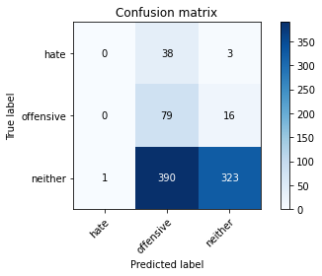

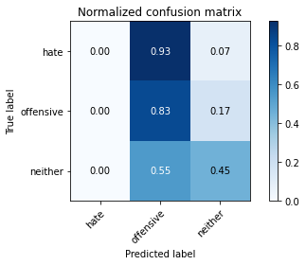

precision recall f1-score support

hate 0.00 0.00 0.00 41

offensive 0.16 0.83 0.26 95

neither 0.94 0.45 0.61 714

accuracy 0.47 850

macro avg 0.37 0.43 0.29 850

weighted avg 0.81 0.47 0.54 850

average eval_loss: 0.9639402946760488, accuracy: 0.47294117647058825

training 3 epoch...

5.589463710784912 seconds used......

3 training finished! average train loss: 0.8316143353780111

evaluating...

Confusion matrix, without normalization

[[ 7 31 3]

[ 6 78 11]

[ 58 256 400]]

Normalized confusion matrix

[[0.17073171 0.75609756 0.07317073]

[0.06315789 0.82105263 0.11578947]

[0.08123249 0.35854342 0.56022409]]

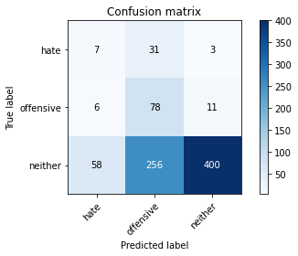

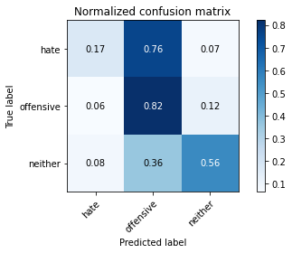

precision recall f1-score support

hate 0.10 0.17 0.12 41

offensive 0.21 0.82 0.34 95

neither 0.97 0.56 0.71 714

accuracy 0.57 850

macro avg 0.43 0.52 0.39 850

weighted avg 0.84 0.57 0.64 850

average eval_loss: 0.9266963635766229, accuracy: 0.5705882352941176

training 4 epoch...

5.591535329818726 seconds used......

4 training finished! average train loss: 0.6511199557118945

evaluating...

Confusion matrix, without normalization

[[ 18 21 2]

[ 19 74 2]

[188 229 297]]

Normalized confusion matrix

[[0.43902439 0.51219512 0.04878049]

[0.2 0.77894737 0.02105263]

[0.26330532 0.32072829 0.41596639]]

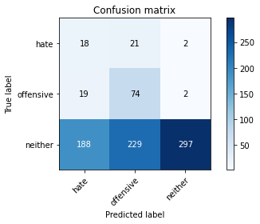

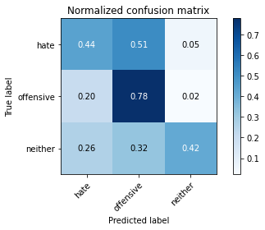

precision recall f1-score support

hate 0.08 0.44 0.14 41

offensive 0.23 0.78 0.35 95

neither 0.99 0.42 0.59 714

accuracy 0.46 850

macro avg 0.43 0.54 0.36 850

weighted avg 0.86 0.46 0.54 850

average eval_loss: 1.1953690454017285, accuracy: 0.4576470588235294

training 5 epoch...

5.557634592056274 seconds used......

5 training finished! average train loss: 0.45829421074854004

evaluating...

Confusion matrix, without normalization

[[ 12 15 14]

[ 9 49 37]

[ 62 82 570]]

Normalized confusion matrix

[[0.29268293 0.36585366 0.34146341]

[0.09473684 0.51578947 0.38947368]

[0.08683473 0.11484594 0.79831933]]

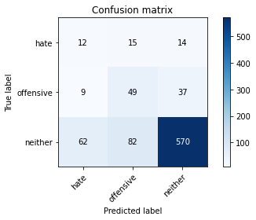

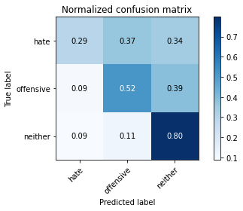

precision recall f1-score support

hate 0.14 0.29 0.19 41

offensive 0.34 0.52 0.41 95

neither 0.92 0.80 0.85 714

accuracy 0.74 850

macro avg 0.47 0.54 0.48 850

weighted avg 0.82 0.74 0.77 850

average eval_loss: 0.6526436463951372, accuracy: 0.7423529411764705

training 6 epoch...

5.557026624679565 seconds used......

6 training finished! average train loss: 0.2806417339791854

evaluating...

Confusion matrix, without normalization

[[ 10 26 5]

[ 14 68 13]

[ 82 198 434]]

Normalized confusion matrix

[[0.24390244 0.63414634 0.12195122]

[0.14736842 0.71578947 0.13684211]

[0.11484594 0.27731092 0.60784314]]

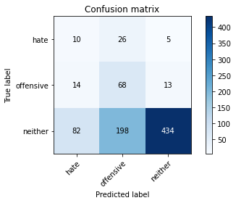

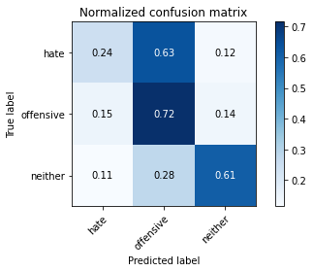

precision recall f1-score support

hate 0.09 0.24 0.14 41

offensive 0.23 0.72 0.35 95

neither 0.96 0.61 0.74 714

accuracy 0.60 850

macro avg 0.43 0.52 0.41 850

weighted avg 0.84 0.60 0.67 850

average eval_loss: 1.0646334060489437, accuracy: 0.6023529411764705

training 7 epoch...

5.6742775440216064 seconds used......

7 training finished! average train loss: 0.14365370054211882

evaluating...

Confusion matrix, without normalization

[[ 12 18 11]

[ 8 54 33]

[ 59 104 551]]

Normalized confusion matrix

[[0.29268293 0.43902439 0.26829268]

[0.08421053 0.56842105 0.34736842]

[0.08263305 0.14565826 0.77170868]]

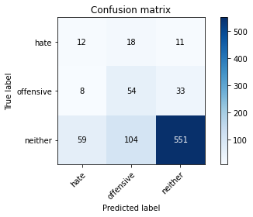

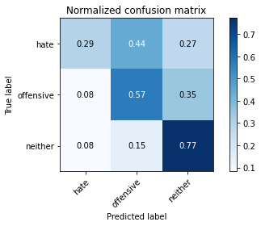

precision recall f1-score support

hate 0.15 0.29 0.20 41

offensive 0.31 0.57 0.40 95

neither 0.93 0.77 0.84 714

accuracy 0.73 850

macro avg 0.46 0.54 0.48 850

weighted avg 0.82 0.73 0.76 850

average eval_loss: 0.7919649299407421, accuracy: 0.7258823529411764

training 8 epoch...

5.595560312271118 seconds used......

8 training finished! average train loss: 0.05720739014860657

evaluating...

Confusion matrix, without normalization

[[ 12 21 8]

[ 12 68 15]

[ 71 147 496]]

Normalized confusion matrix

[[0.29268293 0.51219512 0.19512195]

[0.12631579 0.71578947 0.15789474]

[0.09943978 0.20588235 0.69467787]]

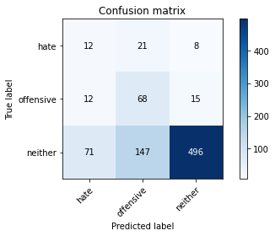

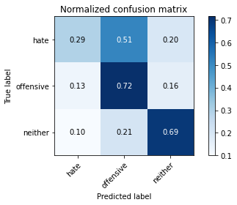

precision recall f1-score support

hate 0.13 0.29 0.18 41

offensive 0.29 0.72 0.41 95

neither 0.96 0.69 0.80 714

accuracy 0.68 850

macro avg 0.46 0.57 0.46 850

weighted avg 0.84 0.68 0.73 850

average eval_loss: 1.0543989098176014, accuracy: 0.6776470588235294

training 9 epoch...

5.5965118408203125 seconds used......

9 training finished! average train loss: 0.023371331600679293

evaluating...

Confusion matrix, without normalization

[[ 18 12 11]

[ 16 60 19]

[ 98 98 518]]

Normalized confusion matrix

[[0.43902439 0.29268293 0.26829268]

[0.16842105 0.63157895 0.2 ]

[0.1372549 0.1372549 0.7254902 ]]

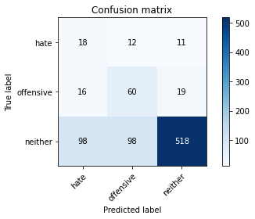

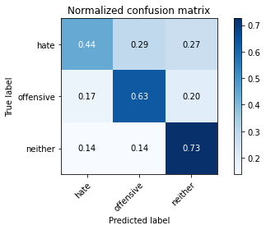

precision recall f1-score support

hate 0.14 0.44 0.21 41

offensive 0.35 0.63 0.45 95

neither 0.95 0.73 0.82 714

accuracy 0.70 850

macro avg 0.48 0.60 0.49 850

weighted avg 0.84 0.70 0.75 850

average eval_loss: 1.0212369586536012, accuracy: 0.7011764705882353

training 10 epoch...

5.554903984069824 seconds used......

10 training finished! average train loss: 0.014899729065493576

evaluating...

Confusion matrix, without normalization

[[ 12 21 8]

[ 13 67 15]

[ 86 152 476]]

Normalized confusion matrix

[[0.29268293 0.51219512 0.19512195]

[0.13684211 0.70526316 0.15789474]

[0.12044818 0.21288515 0.66666667]]

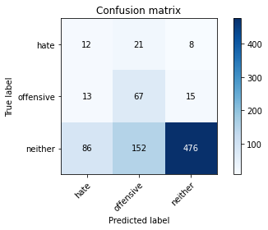

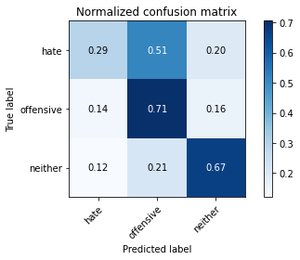

precision recall f1-score support

hate 0.11 0.29 0.16 41

offensive 0.28 0.71 0.40 95

neither 0.95 0.67 0.78 714

accuracy 0.65 850

macro avg 0.45 0.55 0.45 850

weighted avg 0.84 0.65 0.71 850

average eval_loss: 1.3184795664666698, accuracy: 0.6529411764705882

5 run......

training 1 epoch...

5.607236862182617 seconds used......

1 training finished! average train loss: 1.0756305671400495

evaluating...

Confusion matrix, without normalization

[[ 0 39 2]

[ 0 82 13]

[ 3 375 336]]

Normalized confusion matrix

[[0. 0.95121951 0.04878049]

[0. 0.86315789 0.13684211]

[0.00420168 0.52521008 0.47058824]]

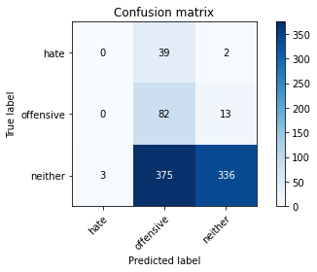

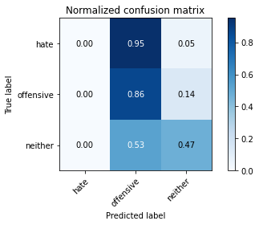

precision recall f1-score support

hate 0.00 0.00 0.00 41

offensive 0.17 0.86 0.28 95

neither 0.96 0.47 0.63 714

accuracy 0.49 850

macro avg 0.37 0.44 0.30 850

weighted avg 0.82 0.49 0.56 850

average eval_loss: 0.9867921804272851, accuracy: 0.49176470588235294

training 2 epoch...

5.554711103439331 seconds used......

2 training finished! average train loss: 0.908954895204968

evaluating...

Confusion matrix, without normalization

[[ 1 39 1]

[ 0 87 8]

[ 1 407 306]]

Normalized confusion matrix

[[0.02439024 0.95121951 0.02439024]

[0. 0.91578947 0.08421053]

[0.00140056 0.57002801 0.42857143]]

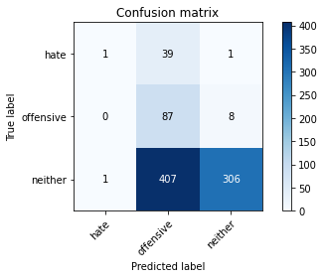

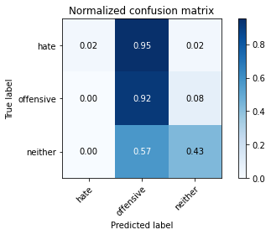

precision recall f1-score support

hate 0.50 0.02 0.05 41

offensive 0.16 0.92 0.28 95

neither 0.97 0.43 0.59 714

accuracy 0.46 850

macro avg 0.54 0.46 0.31 850

weighted avg 0.86 0.46 0.53 850

average eval_loss: 0.9713825313157813, accuracy: 0.46352941176470586

training 3 epoch...

5.56698203086853 seconds used......

3 training finished! average train loss: 0.8245696889029609

evaluating...

Confusion matrix, without normalization

[[ 3 27 11]

[ 0 66 29]

[ 12 197 505]]

Normalized confusion matrix

[[0.07317073 0.65853659 0.26829268]

[0. 0.69473684 0.30526316]

[0.01680672 0.27591036 0.70728291]]

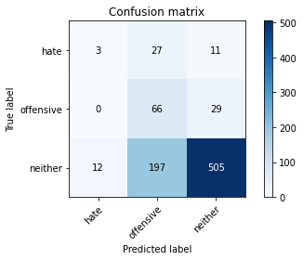

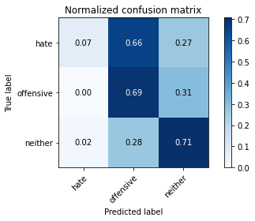

precision recall f1-score support

hate 0.20 0.07 0.11 41

offensive 0.23 0.69 0.34 95

neither 0.93 0.71 0.80 714

accuracy 0.68 850

macro avg 0.45 0.49 0.42 850

weighted avg 0.81 0.68 0.72 850

average eval_loss: 0.7417375188927318, accuracy: 0.6752941176470588

training 4 epoch...

5.571255445480347 seconds used......

4 training finished! average train loss: 0.638592466711998

evaluating...

Confusion matrix, without normalization

[[ 5 19 17]

[ 3 61 31]

[ 27 159 528]]

Normalized confusion matrix

[[0.12195122 0.46341463 0.41463415]

[0.03157895 0.64210526 0.32631579]

[0.03781513 0.22268908 0.7394958 ]]

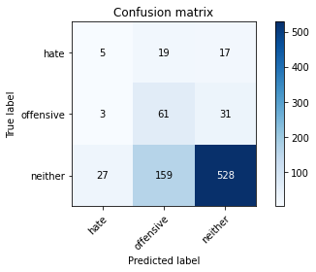

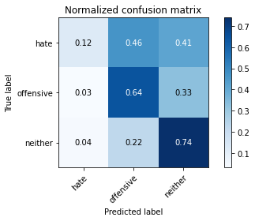

precision recall f1-score support

hate 0.14 0.12 0.13 41

offensive 0.26 0.64 0.37 95

neither 0.92 0.74 0.82 714

accuracy 0.70 850

macro avg 0.44 0.50 0.44 850

weighted avg 0.81 0.70 0.73 850

average eval_loss: 0.6809416584843813, accuracy: 0.6988235294117647

training 5 epoch...

5.584946393966675 seconds used......

5 training finished! average train loss: 0.4371565737658077

evaluating...

Confusion matrix, without normalization

[[ 17 10 14]

[ 26 43 26]

[122 96 496]]

Normalized confusion matrix

[[0.41463415 0.24390244 0.34146341]

[0.27368421 0.45263158 0.27368421]

[0.17086835 0.13445378 0.69467787]]

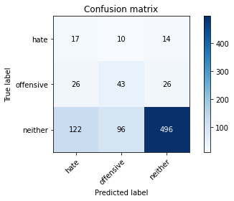

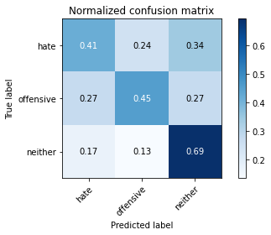

precision recall f1-score support

hate 0.10 0.41 0.17 41

offensive 0.29 0.45 0.35 95

neither 0.93 0.69 0.79 714

accuracy 0.65 850

macro avg 0.44 0.52 0.44 850

weighted avg 0.81 0.65 0.71 850

average eval_loss: 0.813729606655448, accuracy: 0.6541176470588236

training 6 epoch...

5.5876030921936035 seconds used......

6 training finished! average train loss: 0.28569705846409005

evaluating...

Confusion matrix, without normalization

[[ 7 28 6]

[ 6 83 6]

[ 62 296 356]]

Normalized confusion matrix

[[0.17073171 0.68292683 0.14634146]

[0.06315789 0.87368421 0.06315789]

[0.08683473 0.41456583 0.49859944]]

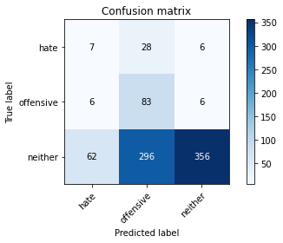

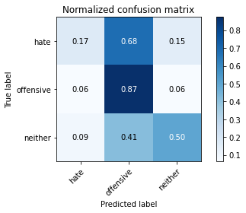

precision recall f1-score support

hate 0.09 0.17 0.12 41

offensive 0.20 0.87 0.33 95

neither 0.97 0.50 0.66 714

accuracy 0.52 850

macro avg 0.42 0.51 0.37 850

weighted avg 0.84 0.52 0.60 850

average eval_loss: 1.2742971306623414, accuracy: 0.5247058823529411

training 7 epoch...

5.699140548706055 seconds used......

7 training finished! average train loss: 0.13626518431637022

evaluating...

Confusion matrix, without normalization

[[ 8 19 14]

[ 3 72 20]

[ 32 192 490]]

Normalized confusion matrix

[[0.19512195 0.46341463 0.34146341]

[0.03157895 0.75789474 0.21052632]

[0.04481793 0.26890756 0.68627451]]

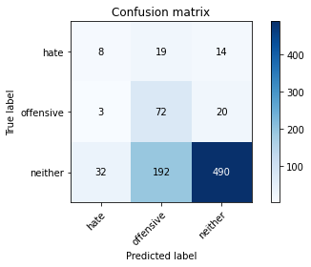

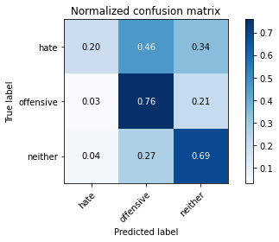

precision recall f1-score support

hate 0.19 0.20 0.19 41

offensive 0.25 0.76 0.38 95

neither 0.94 0.69 0.79 714

accuracy 0.67 850

macro avg 0.46 0.55 0.45 850

weighted avg 0.82 0.67 0.72 850

average eval_loss: 0.9146737899566286, accuracy: 0.6705882352941176

training 8 epoch...

5.577817916870117 seconds used......

8 training finished! average train loss: 0.05266250137032734

evaluating...

Confusion matrix, without normalization

[[ 11 15 15]

[ 9 71 15]

[ 49 179 486]]

Normalized confusion matrix

[[0.26829268 0.36585366 0.36585366]

[0.09473684 0.74736842 0.15789474]

[0.06862745 0.25070028 0.68067227]]

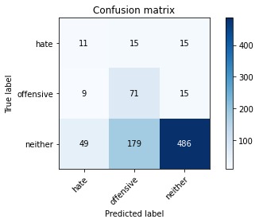

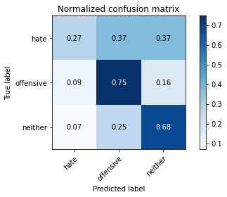

precision recall f1-score support

hate 0.16 0.27 0.20 41

offensive 0.27 0.75 0.39 95

neither 0.94 0.68 0.79 714

accuracy 0.67 850

macro avg 0.46 0.57 0.46 850

weighted avg 0.83 0.67 0.72 850

average eval_loss: 1.0570277562581523, accuracy: 0.668235294117647

training 9 epoch...

5.557476758956909 seconds used......

9 training finished! average train loss: 0.02717779354295797

evaluating...

Confusion matrix, without normalization

[[ 9 18 14]

[ 4 76 15]

[ 37 216 461]]

Normalized confusion matrix

[[0.2195122 0.43902439 0.34146341]

[0.04210526 0.8 0.15789474]

[0.05182073 0.30252101 0.64565826]]

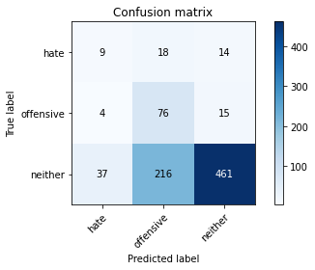

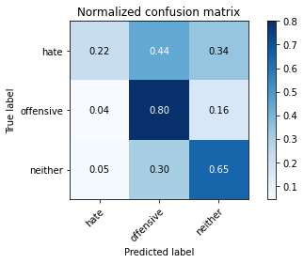

precision recall f1-score support

hate 0.18 0.22 0.20 41

offensive 0.25 0.80 0.38 95

neither 0.94 0.65 0.77 714

accuracy 0.64 850

macro avg 0.46 0.56 0.45 850

weighted avg 0.83 0.64 0.69 850

average eval_loss: 1.1949626864042393, accuracy: 0.6423529411764706

training 10 epoch...

5.550638198852539 seconds used......

10 training finished! average train loss: 0.02206753360870708

evaluating...

Confusion matrix, without normalization

[[ 10 13 18]

[ 17 53 25]

[ 55 136 523]]

Normalized confusion matrix

[[0.24390244 0.31707317 0.43902439]

[0.17894737 0.55789474 0.26315789]

[0.07703081 0.19047619 0.732493 ]]

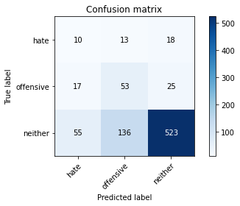

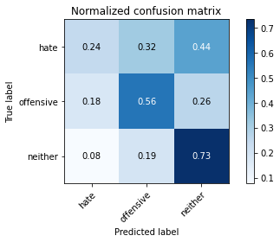

precision recall f1-score support

hate 0.12 0.24 0.16 41

offensive 0.26 0.56 0.36 95

neither 0.92 0.73 0.82 714

accuracy 0.69 850

macro avg 0.44 0.51 0.45 850

weighted avg 0.81 0.69 0.73 850

average eval_loss: 1.0482951906228135, accuracy: 0.6894117647058824